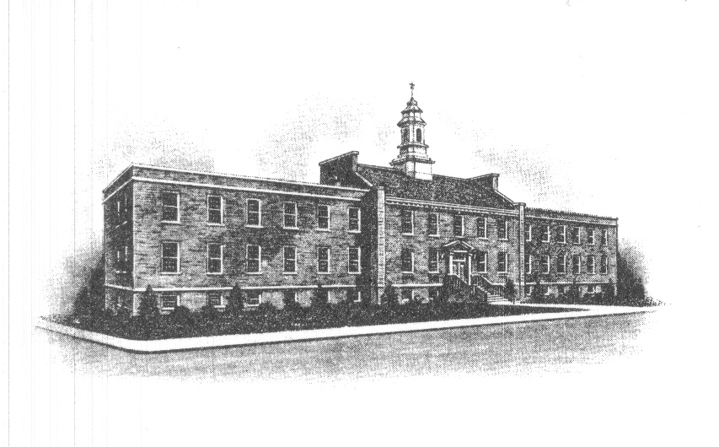
The Borough of Sayreville
Sayreville Board of Adjustment
167 Main Street
Sayreville, NJ 08872
(732) 390-7077 - Phone
(732) 390-7458 - Fax

ZONING BOARD MEETING CANCELLATION ANNOUNCEMENT

Take notice that the regularly scheduled December 12, 2018 meeting of the Zoning Board of Adjustment in the Borough of Sayreville, N.J. has been cancelled and the following application(s) will be carried over/heard on January 23, 2019 at 7:30 PM:

#18-17 Victor DeGirolamo 16 Outlook Ave. Bulk Variance/Addition/Garage/Driveway

There will be no further notice to residents.

The meeting will be held in the main Borough Hall, 167 Main Street, Sayreville, NJ 08872, in the Council Chambers on the 3rd Floor. This notice shall be placed on the meeting room door and filed in the office of the Municipal Clerk, it will be posted on the Borough bulletin board, and noticed in The Home News Tribune. Any applications, plans and documents related to the above application(s) will be available for review in the Construction/Zoning Office located at 49 Dolan Street, Sayreville, NJ during normal working hours 7:30 AM – 4:00 PM.

Joan M. Kemble
Secretary
Zoning Board of Adjustment

